2KF8
Sequence (5’ to 3’) | $$ϵ_{260nm} (M^{-1}cm^{-1})$$ | DOI
GGGTTAGGGTTAGGGTTAGGGT | 223500 | 10.1021/ja807503g

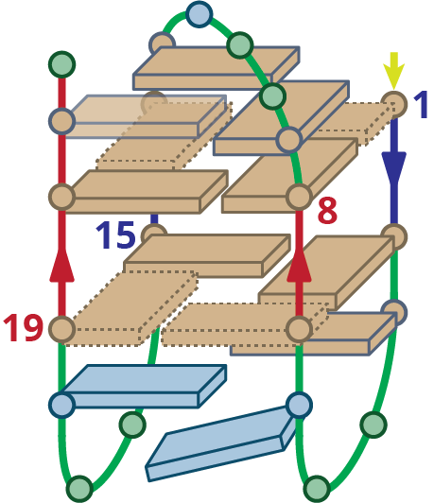
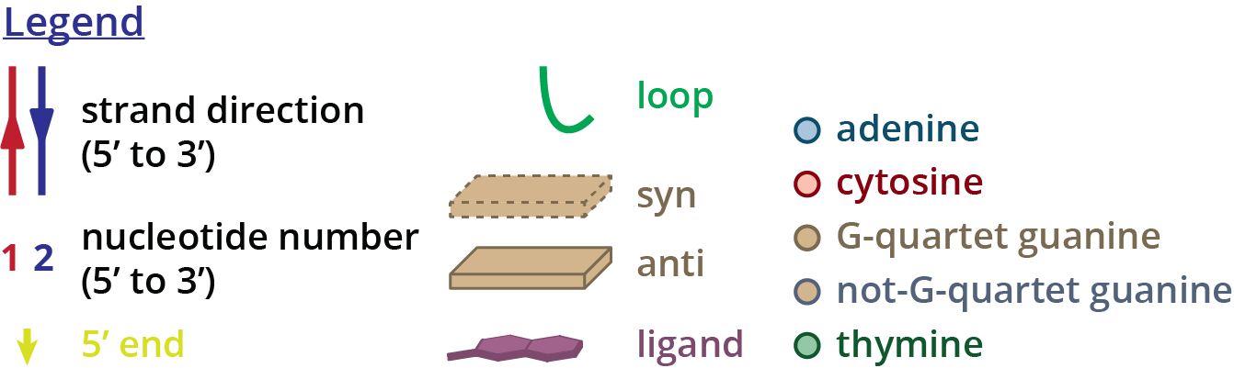
Structure diagram of 2KF8

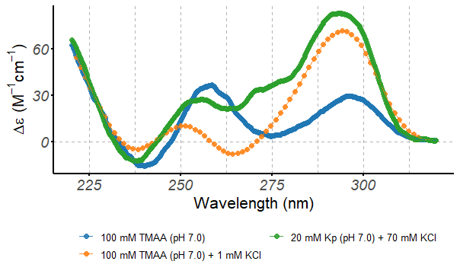
Circular dichroism spectra of the 2KF8 oligonucleotide (10 µM), acquired at 25°C in 0.4-cm path-length cuvettes

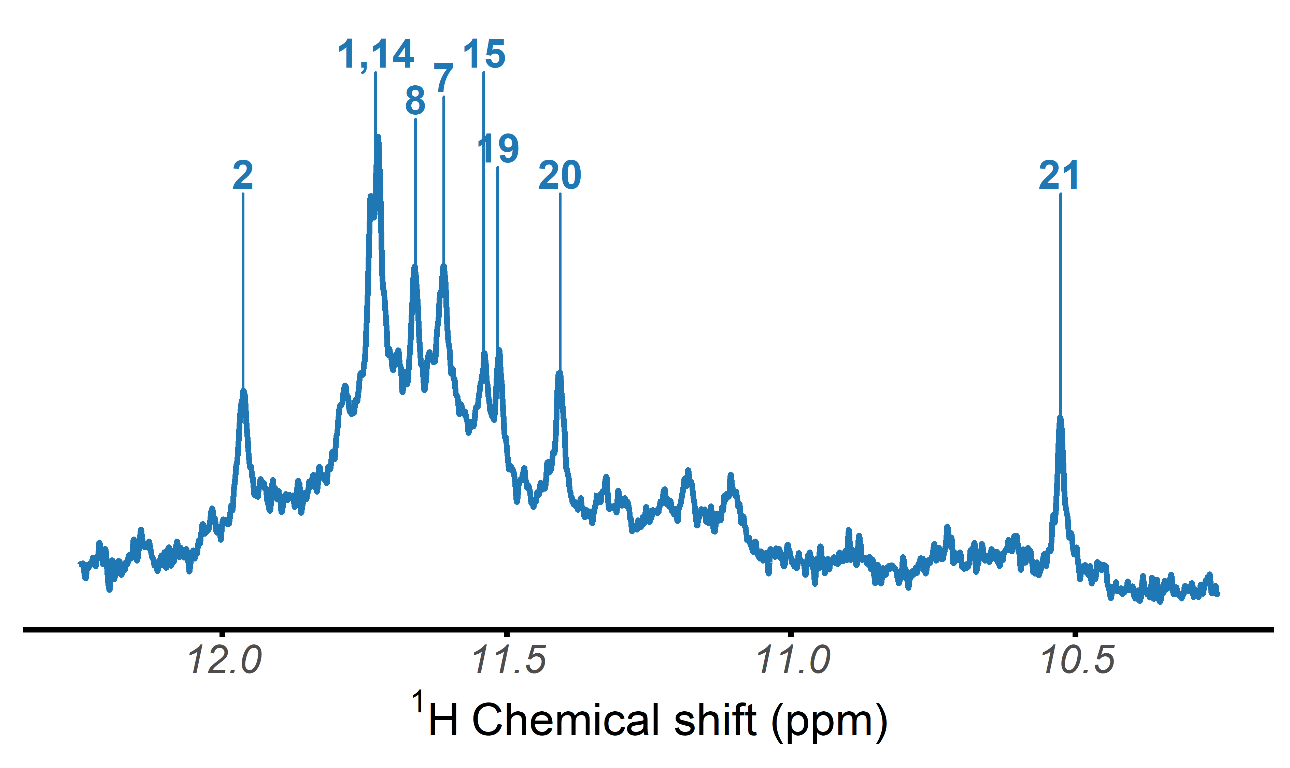
$​^{1}$H-NMR spectrum of the 2KF8 oligonucleotide, acquired at 25°C in 100 mM TMAA (pH 7.0) + 1 mM KCl

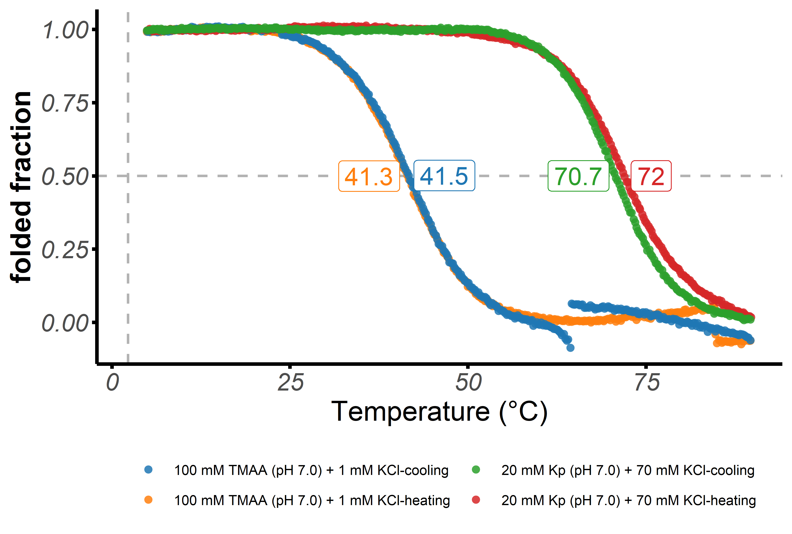
Folded fraction of the 2KF8 oligonucleotide as a function of temperature, determined by UV-melting ($λ$ = 295 nm)

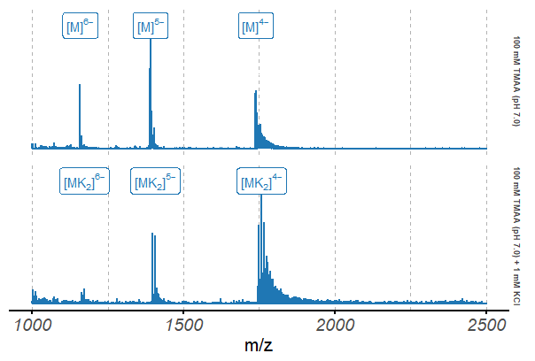
Native ESI-MS spectra of the 2KF8 oligonucleotide (10 µM)

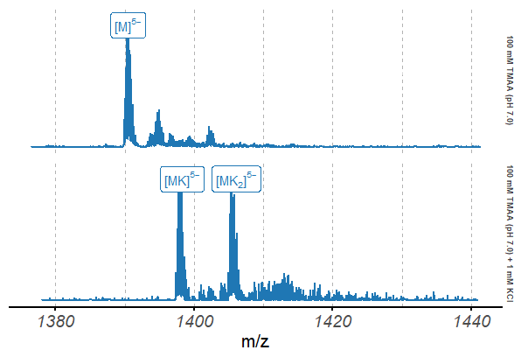
Native ESI-MS spectra of the 2KF8 oligonucleotide (10 µM), focused on the 5$​^{-}$ charge state

